10 most amazing palaces from around the world

Hello Travelers

We have all probably daydreamed at one point about being royalty and living in an opulent palace while being waited on hand and foot. Well, while you may not be royalty there are a lot of amazing palaces around the world that you can go and visit. Sure, it's not quite the same thing as being a king or a queen but at least it can make your daydreams a bit more vivid.

With so many palaces around the world, it can be hard to break down which ones are worth visiting so we compiled a list to make it easy.

But before we get started, like the video and subscribe to the channel so you won't miss future videos.

Welcome to Tenzies Travel, here is our list of the top 10 most amazing palaces from around the world.

# Buckingham PalaceNumber 10. Buckingham palace

One of most renowned and photographed palaces on Earth, Buckingham Palace in London has long been the throne of the British kings. Originally built in 1703 to be a big townhouse, throughout the years, it was steadily extended and renovated, with its renowned front completed in 1911.

In total, the palace contains 775 rooms, with many of them filled with wonderful furniture, exquisite paintings, and age-old sculptures. Of them, the most spectacular are the cabins. These are available to the public in August and September and are where visiting heads of state stay when in London.

# Number 9. Schonbrunn Palace

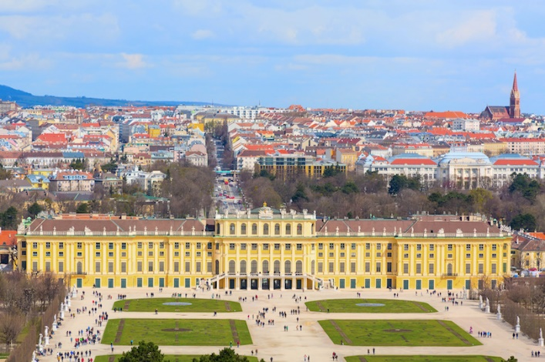There are several reasons why Schonbrunn Palace is a famous tourist destination in Austria. Originally the summer rest house of the Hapsburgs and the place where Emperor Franz Joseph I was born, this magnificent Rococo mansion is painted a bright yellow to fascinate all tourists on the go.

In total, just 40 of the hotel's 1,441 rooms are available to the public. With it, it's vast gardens are a joy to wander through. The zoo, which was previously the royal menagerie, is home to a beautiful botanical garden and orangeries.

# Number 8. Potala palace

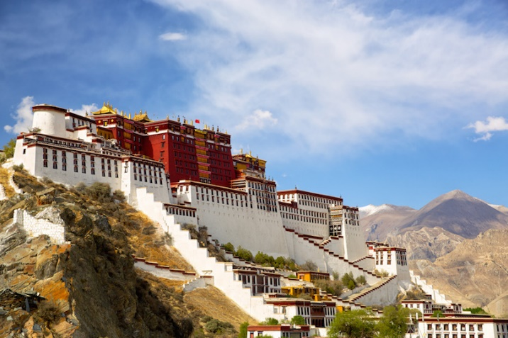Potala Palace has long been considered one of Tibet's most important and stunning structures due to its spectacular location at the top of Marpo Ri hill in the heart of Lhasa Valley. The red and white palace, which was formerly the Dalai Lama's winter home, was built in 1649, although older versions had been on the same site since at least the 7th century.

A total of more than 200,000 sculptures are said to be scattered throughout the temple's corridors, hallways and sacred rooms. Enough to awe you at every sight, Potala Palace is surrounded by high mountains and is a lasting emblem of Tibetan Buddhism, all thanks to its superficial location.

# Number 7. Chateau de Chambord

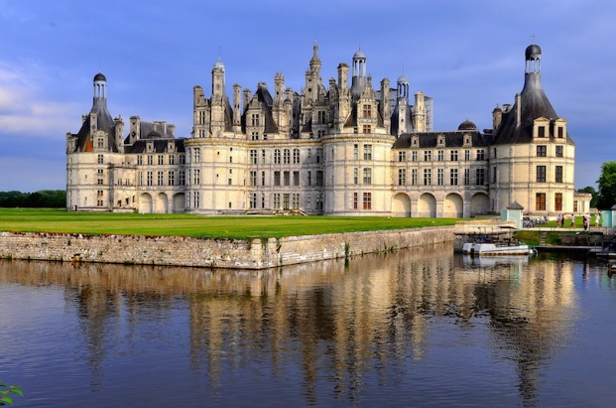Chateau de Chambord, tucked away in the Loire Valley, is unquestionably the pinnacle of French Renaissance architecture. As a hunting lodge, it was commissioned by Francis I to demonstrate the monarch's wealth and authority.

There's still a lot to see and do here, even if many of its magnificent furnishings were stripped and destroyed during the French Revolution. There is little doubt about it, though, that the chateau is an impressive sight, especially in contrast to the beautiful grounds and reflecting moat that surround it.

# Number 6. Hawa Mahal

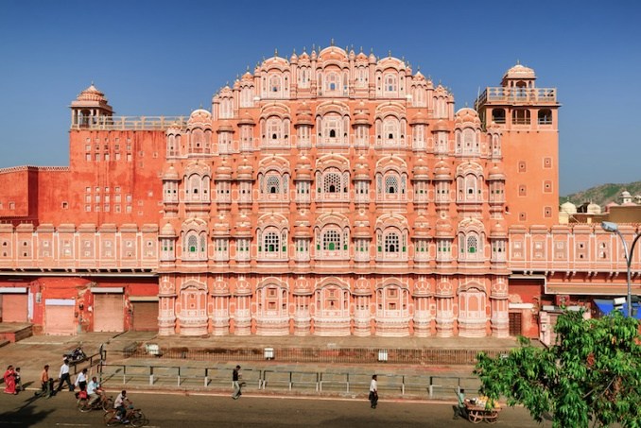Known for its magnificent exterior, Hawa Mahal translates to "Palace of Winds" in English, which is a pleasant surprise. Its beautiful pillars, graceful arches, and dignified domes were all built in 1799 from Jaipur's famous red and pink sandstone.

However, it is the honeycomb-like portico of the palace that draws the most attention. With their colourful glass windows and exquisite latticework, the palace's magnificent bays on five levels are a sight to behold.

# Topkapi PalaceNumber 5. Topkapi Palace

The sultans ruled the Ottoman Empire from Topkapi Palace, which is located on the shores of the Bosphorus. Mehmet the Conqueror ordered the palace to be built in 1459, and it has several ornate and extravagant chambers that showcase some outstanding Islamic art and architecture.

Visitors can explore the Imperial Harem and Imperial Treasury, as well as the beautiful halls and courtyards. Istanbul's Topkapi Palace, now a spectacular museum, is one of the city's most famous tourist attractions.

# Number 4. Palace of Versailles

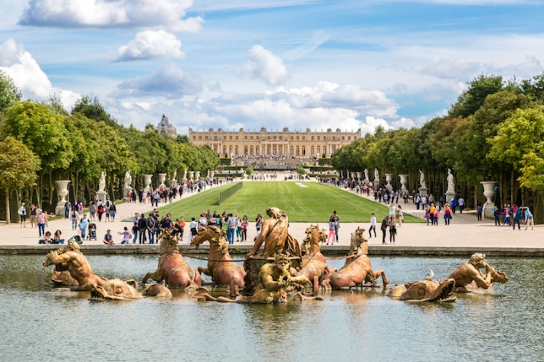Versailles began as a modest hunting lodge, but under Louis XIV, it was transformed into one of the biggest and grandest palaces in history. As time went on, the Sun King expanded it and extended it until it became his royal home and center of administration.

In addition to the magnificent Royal apartments, the brilliant Hall of Mirrors, and the Royal Opera, the Palace of Versailles is now one of France's top tourist attractions. In addition, its magnificent gardens with their spectacular fountains and flowerbeds are also well worth seeing.

# Number 3. Alhambra

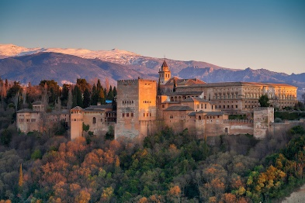Overlooking the city, Alhambra is one of the world's most famous palaces. Andalusian architecture is everywhere you look at this massive complex, which was built in the 13th century by Nasrid Sultans.

Walking through its lush greenery and colonnaded courtyards is an absolute treat. The Museum of Fine Arts offers a wonderful collection of artworks for tourists to enjoy.

# Winter PalaceNumber 2. Winter Palace

The Winter Palace, formerly the residence of the Russian tsars, today houses the Hermitage Museum, one of the world's most famous museums. More than 1,500 chambers, each ornately constructed and furnished, are claimed to be housed within its apparently endless green and white walls.

The grandeur and magnitude of the palace, as well as the exquisite art and architecture on display, eloquently illustrates the strength and might of Imperial Russia throughout the 18th and 19th centuries.

When the Winter Palace was assaulted in 1917 as part of the Russian Revolution, the monarchy and empire came crumbling down. It's no secret that Saint Petersburg's palace and museum are some of the city's most popular attractions.

# Number 1. Forbidden City#1 of Most Beautiful Palaces In The World

Built in 1406, the Forbidden City has dominated Beijing and China as a whole. Emperors from both the Ming and Qing dynasties presided over their vast empires from here.

The palace complex is spread over a large area and is defended by a high wall and a huge moat. The Hall of Supreme Harmony and the Palace of Heavenly Purity are just two of the must-see sites.

With that being said, we just reached the end of our list of ten most amazing palaces! Let us know about your favourite palaces and don’t forget to comment if you have visited or want to visit any of these palaces!

Don’t forget to like our video and subscribe to our channel to get updates about all of our amazing videos! See you soon.